Index performance (5d): SPY +0.8%, DIA +0.3%, IWM +2.3%, QQQ +1.3%, EEM -1.1%, EFA +0.2%, TLT -0.1%, GLD -0.1%
TTG Market View
US Markets rebounded nicely last week, SPY found support at the 50d MA (Moving Average), and IWM at the 100d MA. These were the two key levels to watch that I detailed in last week’s newsletter. In addition, Crude rallied 5.5% last week, just in the nick of time. We are now in a new trading month and new quarter, a great time to reflect on what has worked in your portfolio and more importantly in my opinion, what has not worked in order to correct any mistakes or strategies that are not working.
In the Index Review section below I breakdown all the new support levels to watch in the new April value areas. Here is also a video to watch on whether it is worth it to sell a SPY iron condor: https://youtu.be/L0SWZHjy9x0 . Believe it or not we will be entering earnings season in a little more than a week, which is always a tricky time to trade so selling a little premium here makes sense to me (see video). Next week in US economics, ISM data & Construction Spending is on Monday, Trade Data and Durable Goods data on Tuesday, and Jobs data on Friday will all be important to see if the US economy is continuing to grow.
One observation that I have noticed the last couple weeks in ETF fund flows data is that there is not a ton of money being put to work in the US at least not at the fast pace that we saw in the weeks and months after the election. Instead new money is being put to work in International areas of the market and in the US its just being rotated around from sector to sector. Indeed, this will be interesting in the coming weeks to see if this is a longer trend taking shape or just a catch-up trade between International areas and the US. I do not pretend to have the answer here, one never knows how long a trend will be in effect for (although many try to predict incorrectly). Instead I want to stay long International areas until they break support and that is my game plan for now.
Transports were another area that had a nice recovery last week +2% and rallied back up to the 100d MA. I am displaying the IYT ETF here because I think the Transports are at am important crossroads – they have rallied back to the 100d MA and need to power through, if not it could be a false rally last week.
IYT 1yr chart
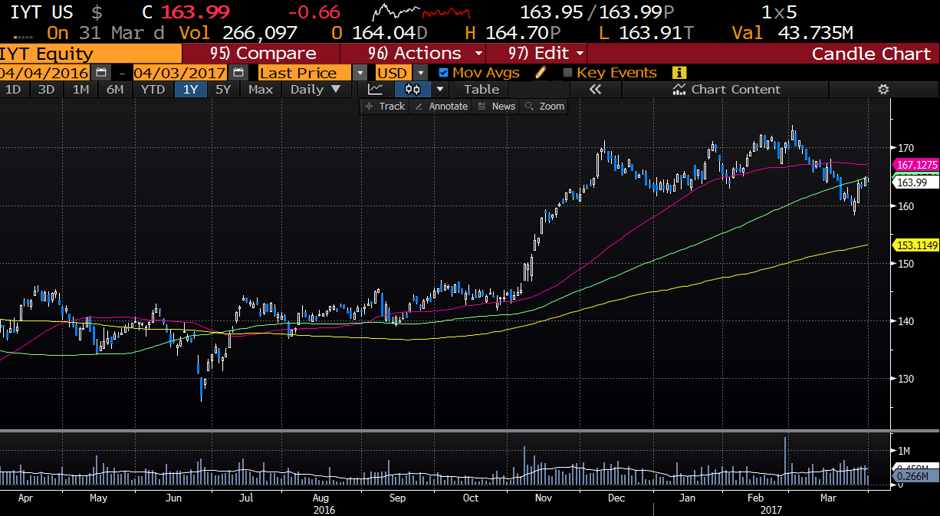
Index Review

Subscribe here to read our full weekend newsletter plus BECOME A MEMBER OF TTG:
http://www.tribecatradegroup.com/products/

